HLK4/45-00

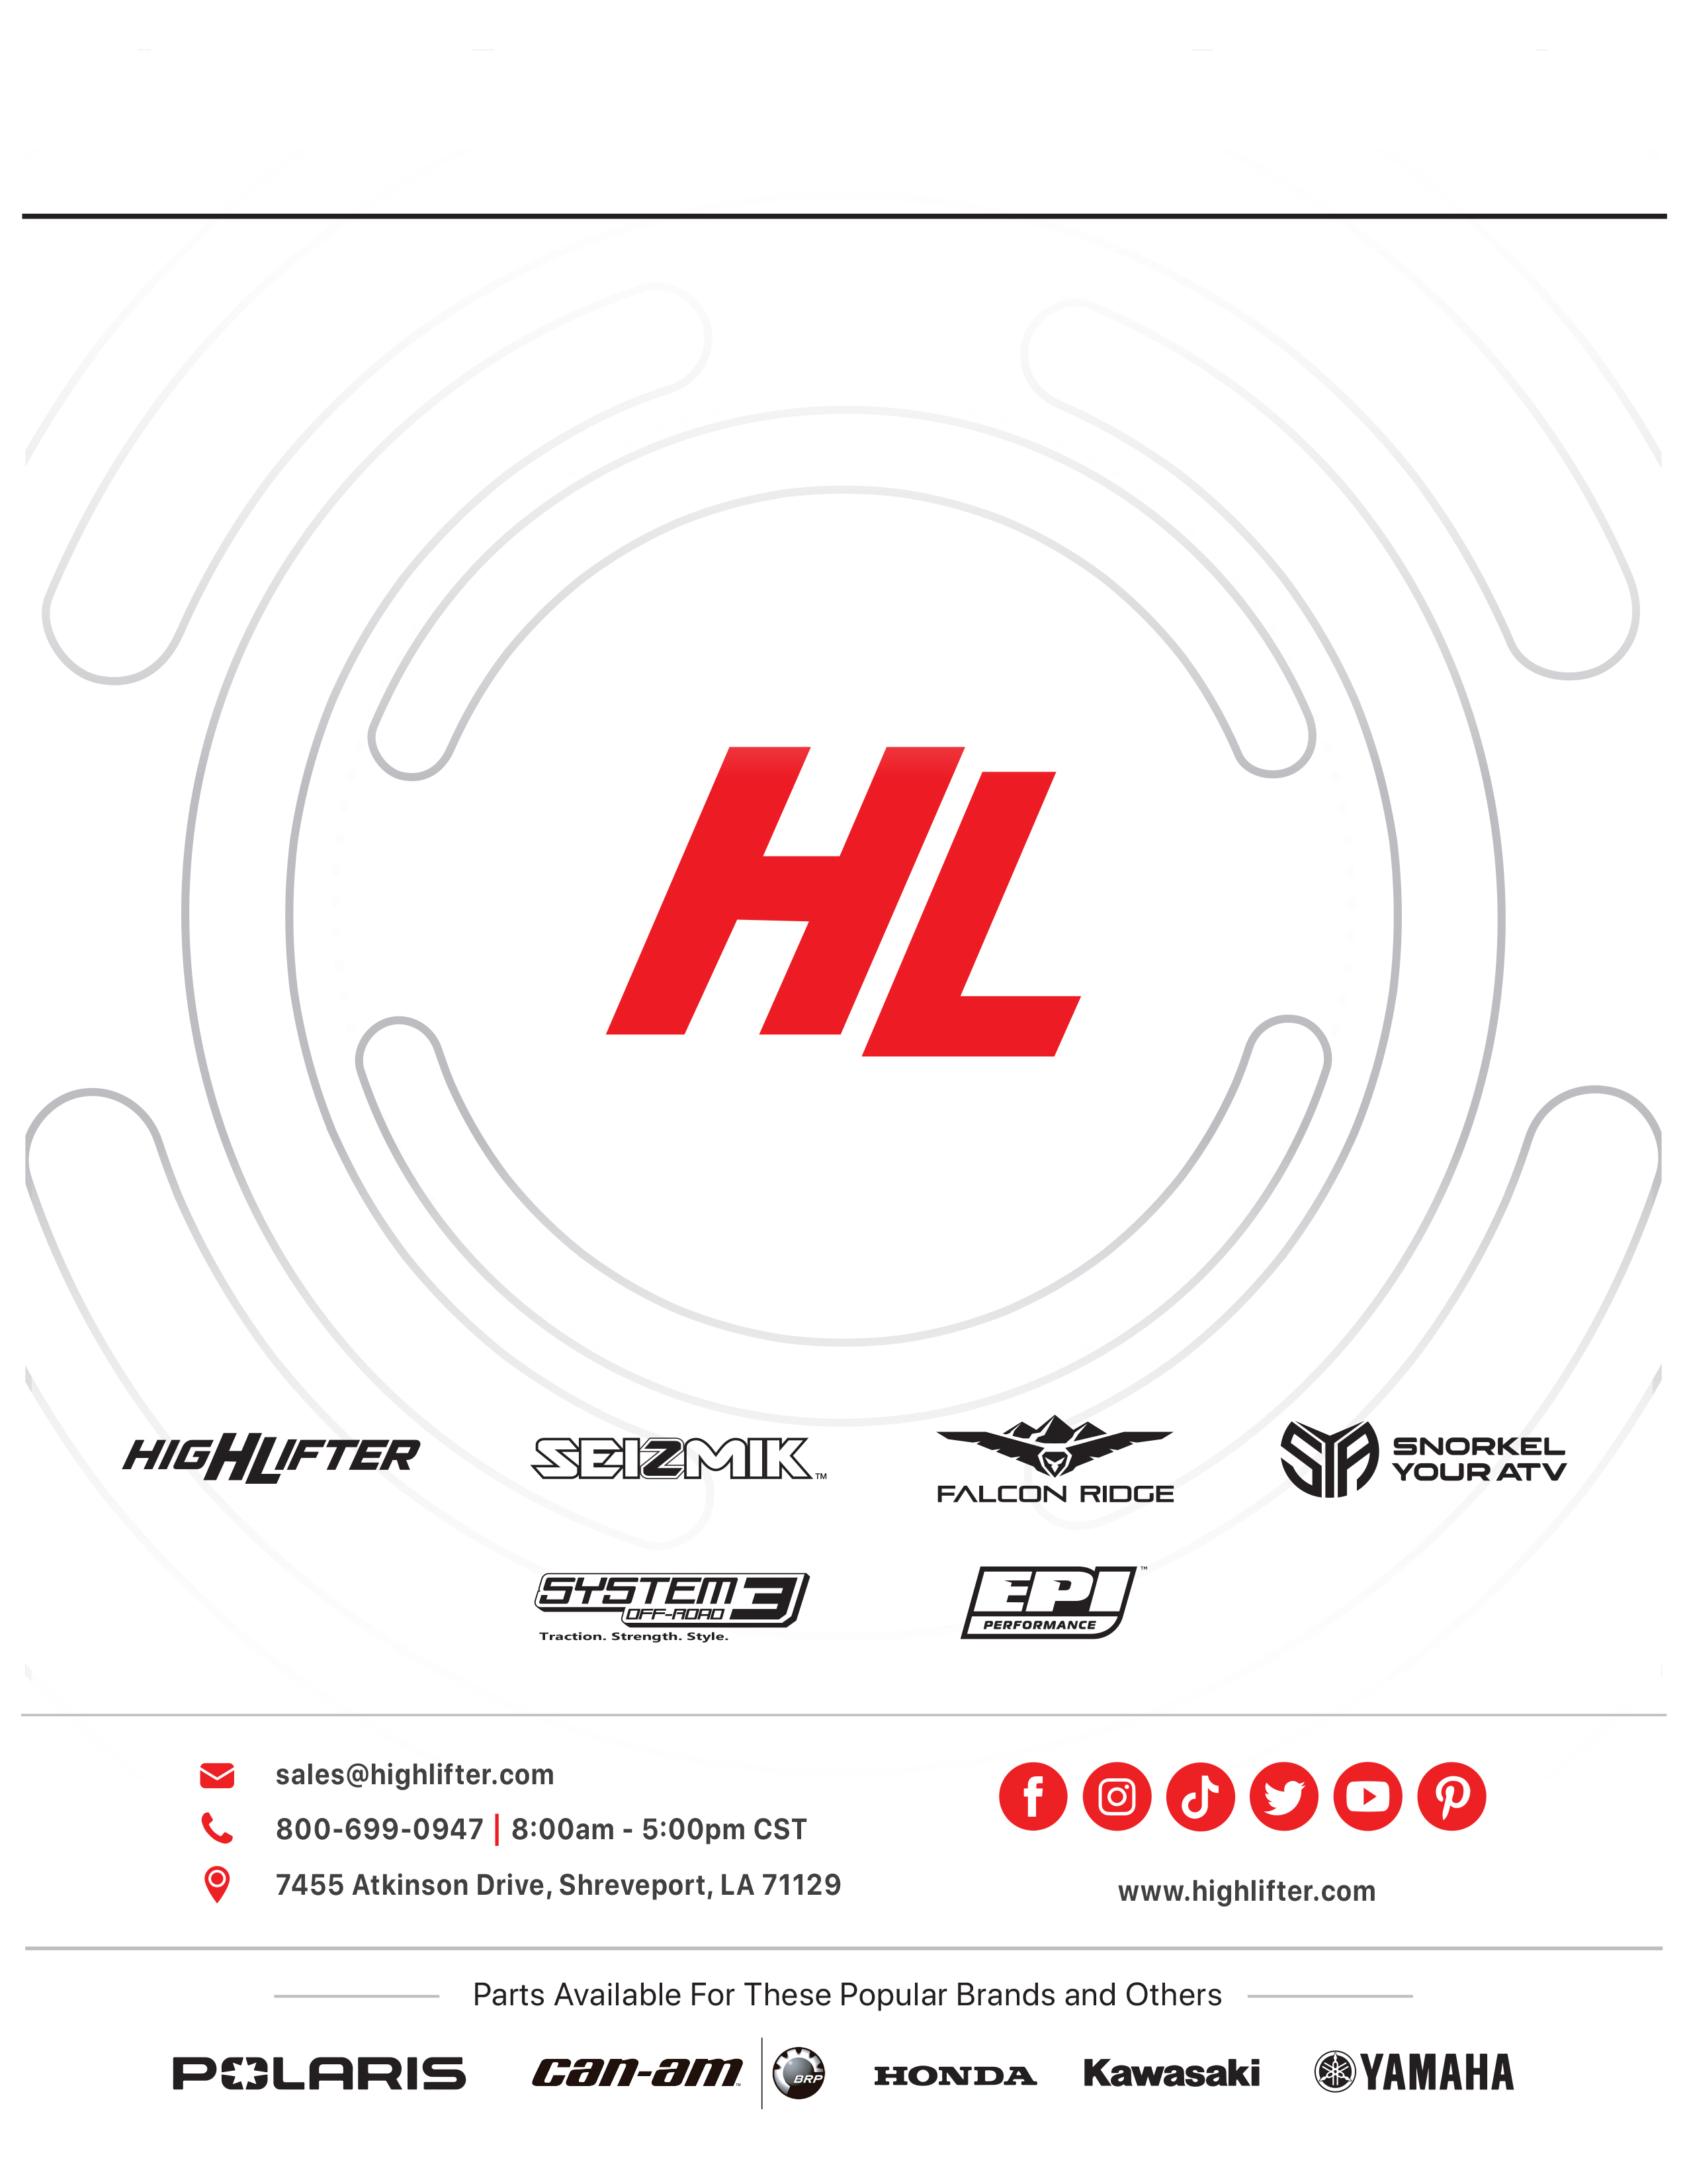

Read before Installation
This product is designed for use on ATVs and/or RUVs to increase ground clearance and fender clearance. Purchasers should be aware that use of this product may increase the frequency of required maintenance, part wear, and will raise the center of gravity on your ATV and/or RUV, increasing risk of roll-over, injury and death on all types of terrain. It is your responsibility to always inform other operators and passengers of this vehicle about the added risks.

High Lifter Products, products are designed to best fit users ATV/RUV under stock conditions. Adding, modifying, or fabricating any OEM or aftermarket parts will void warranty. High Lifter Products, products could interfere with other aftermarket accessories. If the user has aftermarket products on machine, contact High Lifter Products to verify that they will work together. Adding aftermarket suspension components and/or more aggressive tires can cause breakage of other OEM driveline components such as differentials, axles or drive shafts.

We recommend that wider tires and/or wheel spacers be used to achieve a wider stance and to improve stability of the ATV and/or RUV. Riders should be advised that the handling characteristics of a taller ATV and/or RUV are different and require extra care when riding, particularly on side hills or off-camber situations. If you further raise the center of gravity by adding taller tires, heavy loads to racks or seats, or by any other means, the ATV and/or RUV must be operated with even more care, at slower speeds and on relatively flat ground. All turns should be done at a slow speed, even on level ground.

Operation of an ATV and/or RUV with or without modified suspension components, while or shortly after consuming alcohol or drugs, subjects the rider to the risk of serious bodily harm or possible death. This risk is compounded if the rider does not wear an approved helmet and other safety gear. High Lifter urges that all approved safety gear be worn when riding an ATV and/or RUV as a driver or passenger.

By purchasing and installing High Lifter Products, products, user agrees that should damages occur, High Lifter Products will not be held responsible for loss of time, use, labor fees, replacement parts, or freight charges. High Lifter Products will not be held responsible for any direct, indirect, incidental, special, or consequential damages that result from any product purchased from High Lifter Products. The total liability of seller to user for all damages, losses, and causes of action, shall not exceed the total purchase price paid for the product that gives rise to the claim.

Dealers and other Installers
You are responsible for informing your customer and end user of the information contained above and the increased potential hazards of operating an ATV and/or RUV equipped with modified suspension components. If you install any suspension modifying components, it is your responsibility to also install the warning label prominently in view of the driver and in prominent view of the driver and passenger on RUVs and multi-passenger ATVs. They should also be instructed to notify anyone operating the vehicle, as well as any passengers, that said vehicle is modified.

As discussed above, it is critically important that they be instructed in the need for slower speed operation, regardless of terrain, after this lift kit is installed.

This lift kit contains the following parts:
10x45mm Bolts 6
10mm Nuts 6
10mm Flat Washers 5
¼” x 1 ¼” Hex Head Bolt 4
¼” Nuts 4
Lift Brackets 15

Front Lift
- Place jack under center of ATV front end and lift until front wheels clear the ground. Be careful to support ATV properly so that it is secure, but so that the A-arms and shocks can droop to full extension.
- Remove front wheels and shock.
- Slide bottom of lift bracket “A” over A-arm shock mount then insert spacer “C”. Insert one of the new 10x45mm bolts through the bottom hole of bracket “A” and through spacer “C”.
- Put the bottom of the shock into the top of lift bracket “A”. Put one flat washer on each side of shock eyelet and insert one of the new 10x45mm bolts. Now slide lift bracket “B” onto the top bolt. This bracket goes on the front side of the back A-arm.
- Place the ¼” x 1 ¼” Hex Head Bolt through bracket “B” and place bracket “I” on the opposite side of the arm from bracket “B”, secure the ¼” x 1 ¼” Hex Head Bolts with the ¼” nut.
- Now secure the top 10x45mm bolt with a 10mm nut.
- Repeat the procedure for the other side.
- The bracket should angle inward towards the shock keeping the original shock angle when lift is installed correctly or serious tire damage can occur. (It is OK for the shock to lean in slightly but it should not lean out)
- Tighten all bolts to manufacturer’s torque specifications.
- Install the wheels, torque wheel lug nuts to manufacturer’s specifications, lower and remove jack. Check for clearance problems or misalignment.

Rear Lift
Left Side
- Place jack under ATV at the rear of the bottom skid plate and lift until the weight is off of the suspension. Be careful to secure the ATV properly so as not to fall off the jack.
- Remove both rear shocks. (The lift can be installed with the top of the shock on, but this can make it more difficult to align the lift brackets)
- After removing the shocks, jack the ATV up an additional 1”-2”.
- Remove the two top nuts on the left side of the differential housing.
- Insert one of the new 10mm bolts through the end of the bracket “H” (see diagram)
- Install bracket “H” on the two differential housing studs, replace the nuts and torque.
- Slide the left shock onto the new bolt, placing a flat washer on the left side of the shock.
- Install bracket “F” on the outside of the left shock mount (the “V” should fit around the flange)
- Insert the factory bolt through the lower hole on the bracket “F” and through spacer “C”.
- Install a new nut on the new top bolt.
Right Side
- Install bracket “F” on the outside (right) of the original shock mount (the “V” should fit around the flange)
- Install bracket “G” between the factory shock (left side) mounts with spacer “E” (shortest).
- Insert the factory bolt through the bottom hole and install nut.
- Insert a new 10mm bolt through the top holes of both lift brackets and the shock.
- Remove the top rear nut on the axle house and install bracket “D” on this bolt and the top bolt through lift bracket “G”.
- Replace the top shock bolt.

Both Sides
Tighten all bolts to manufacturer’s torque specifications. Install the wheels, torque wheel lug nuts to manufacturer’s specifications, lower and remove jack. Check for clearance problems or misalignment.

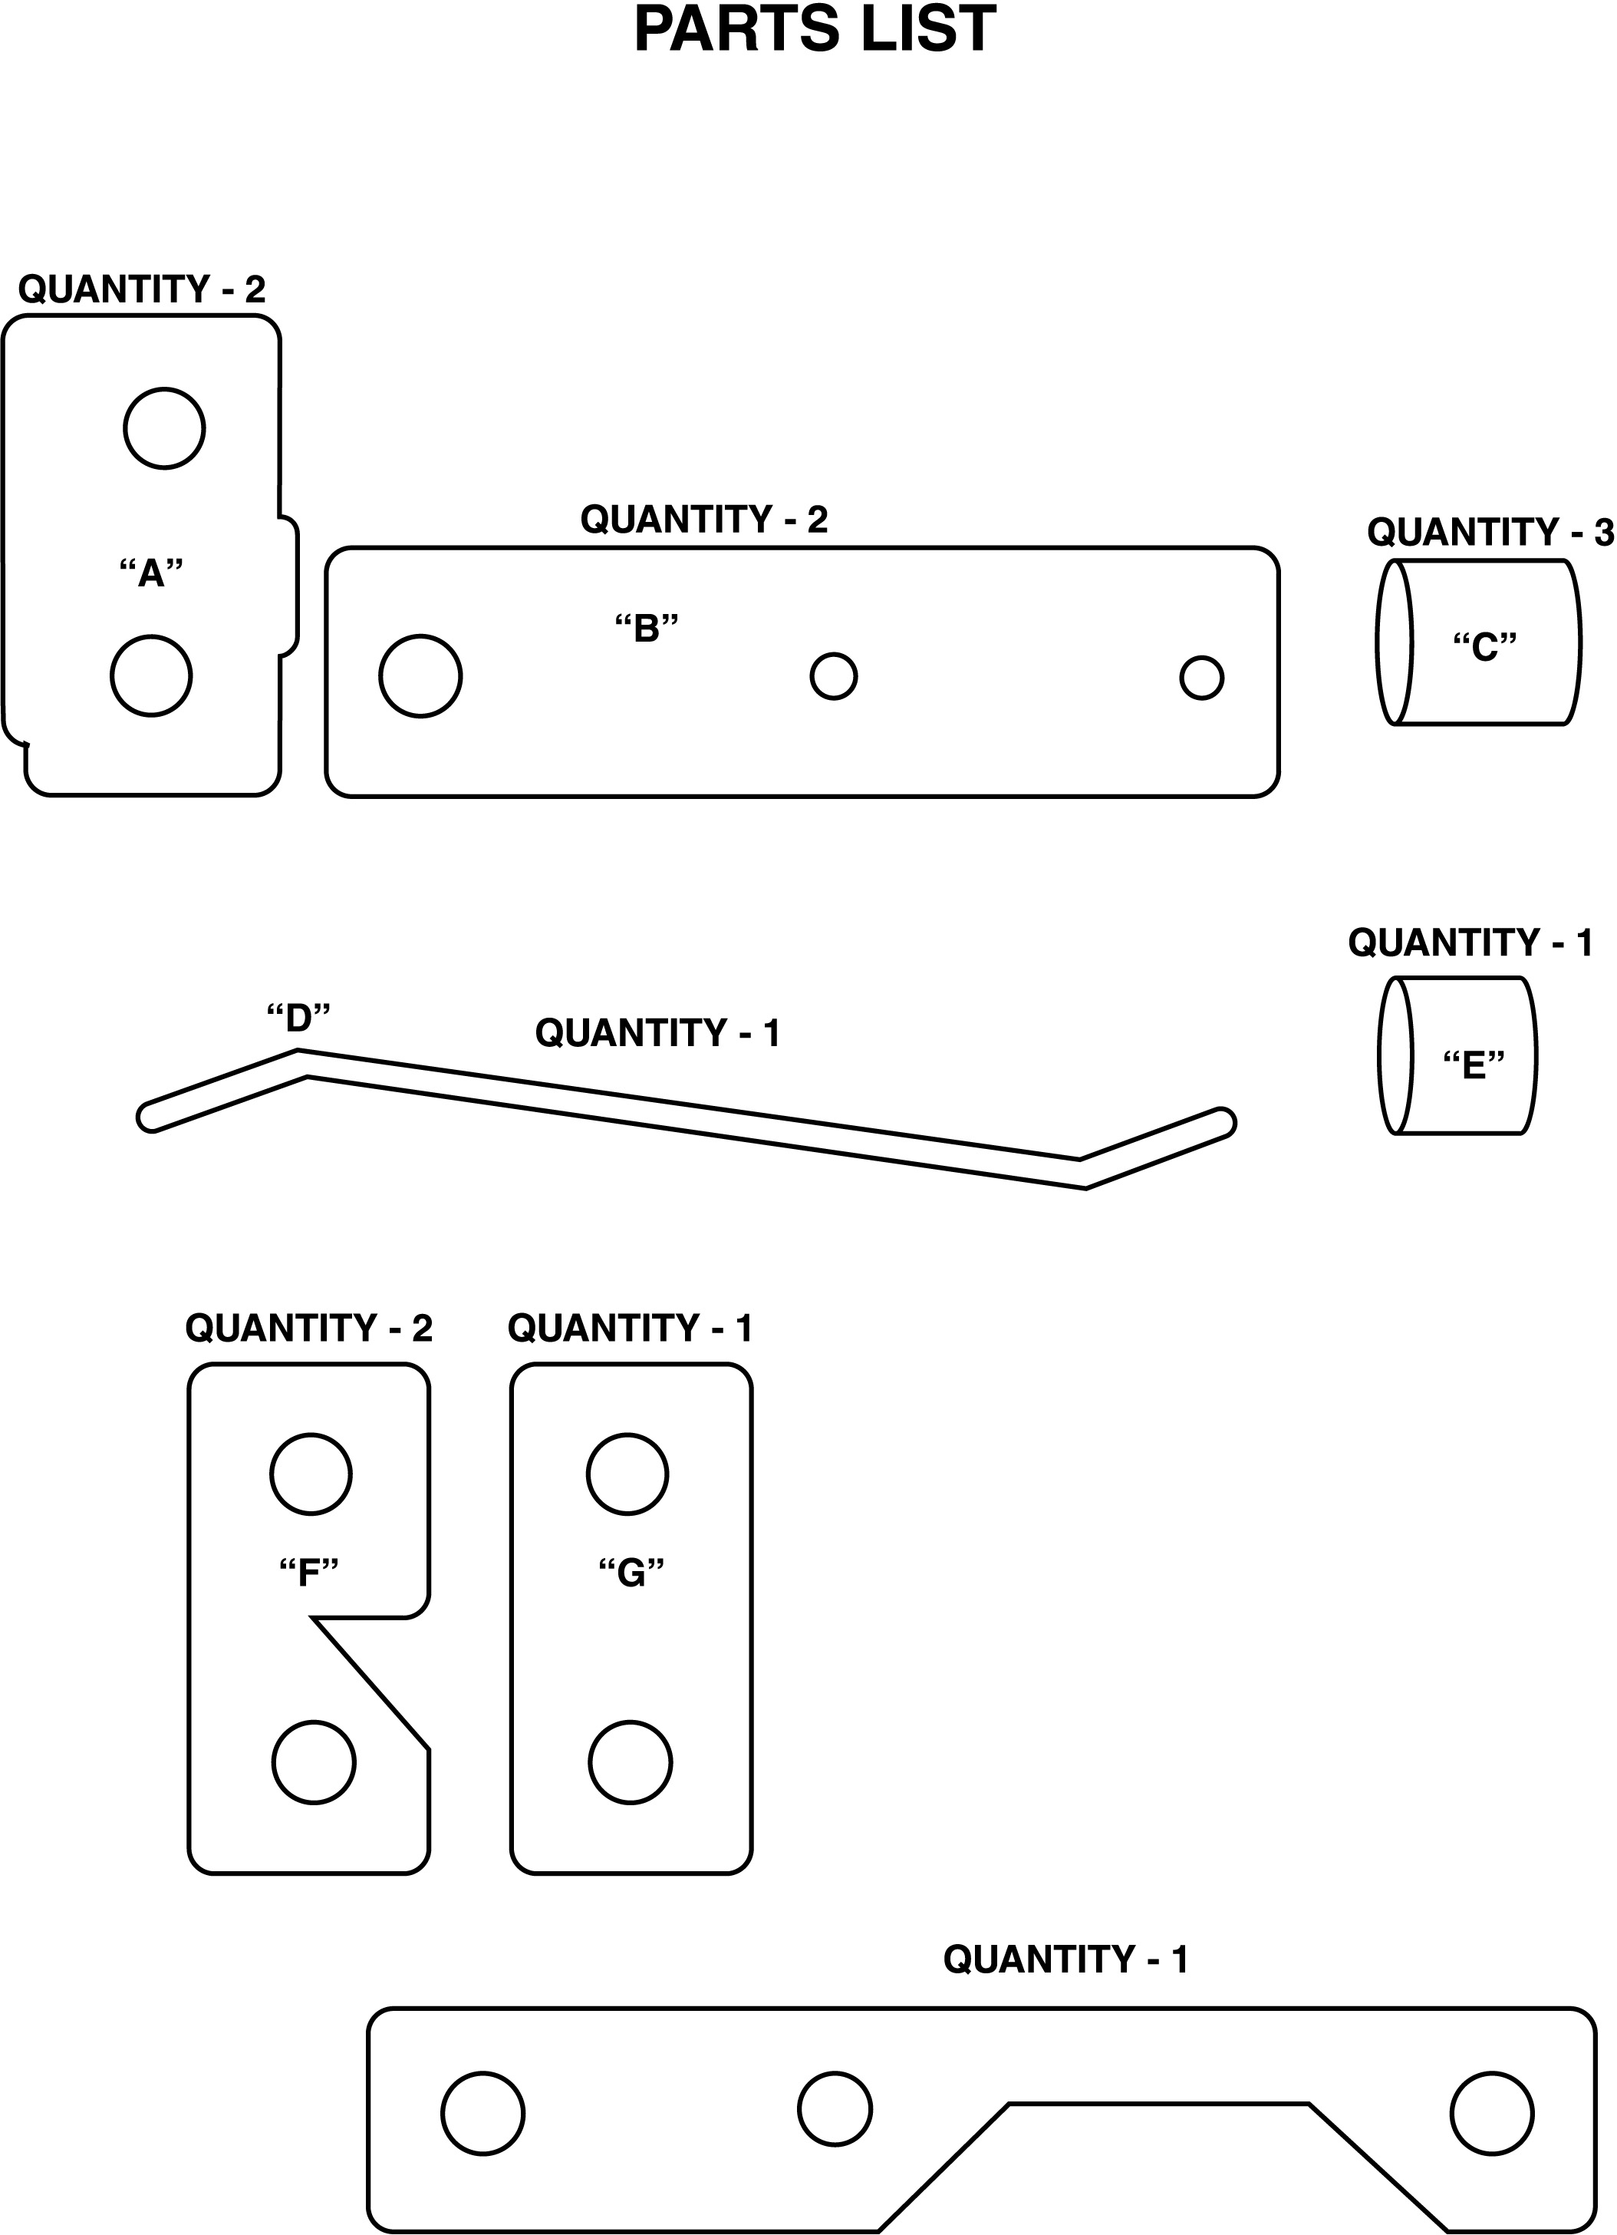

3U

G

E

A
F

QUANTITY - 2

“I”

B III
C

“H”

D
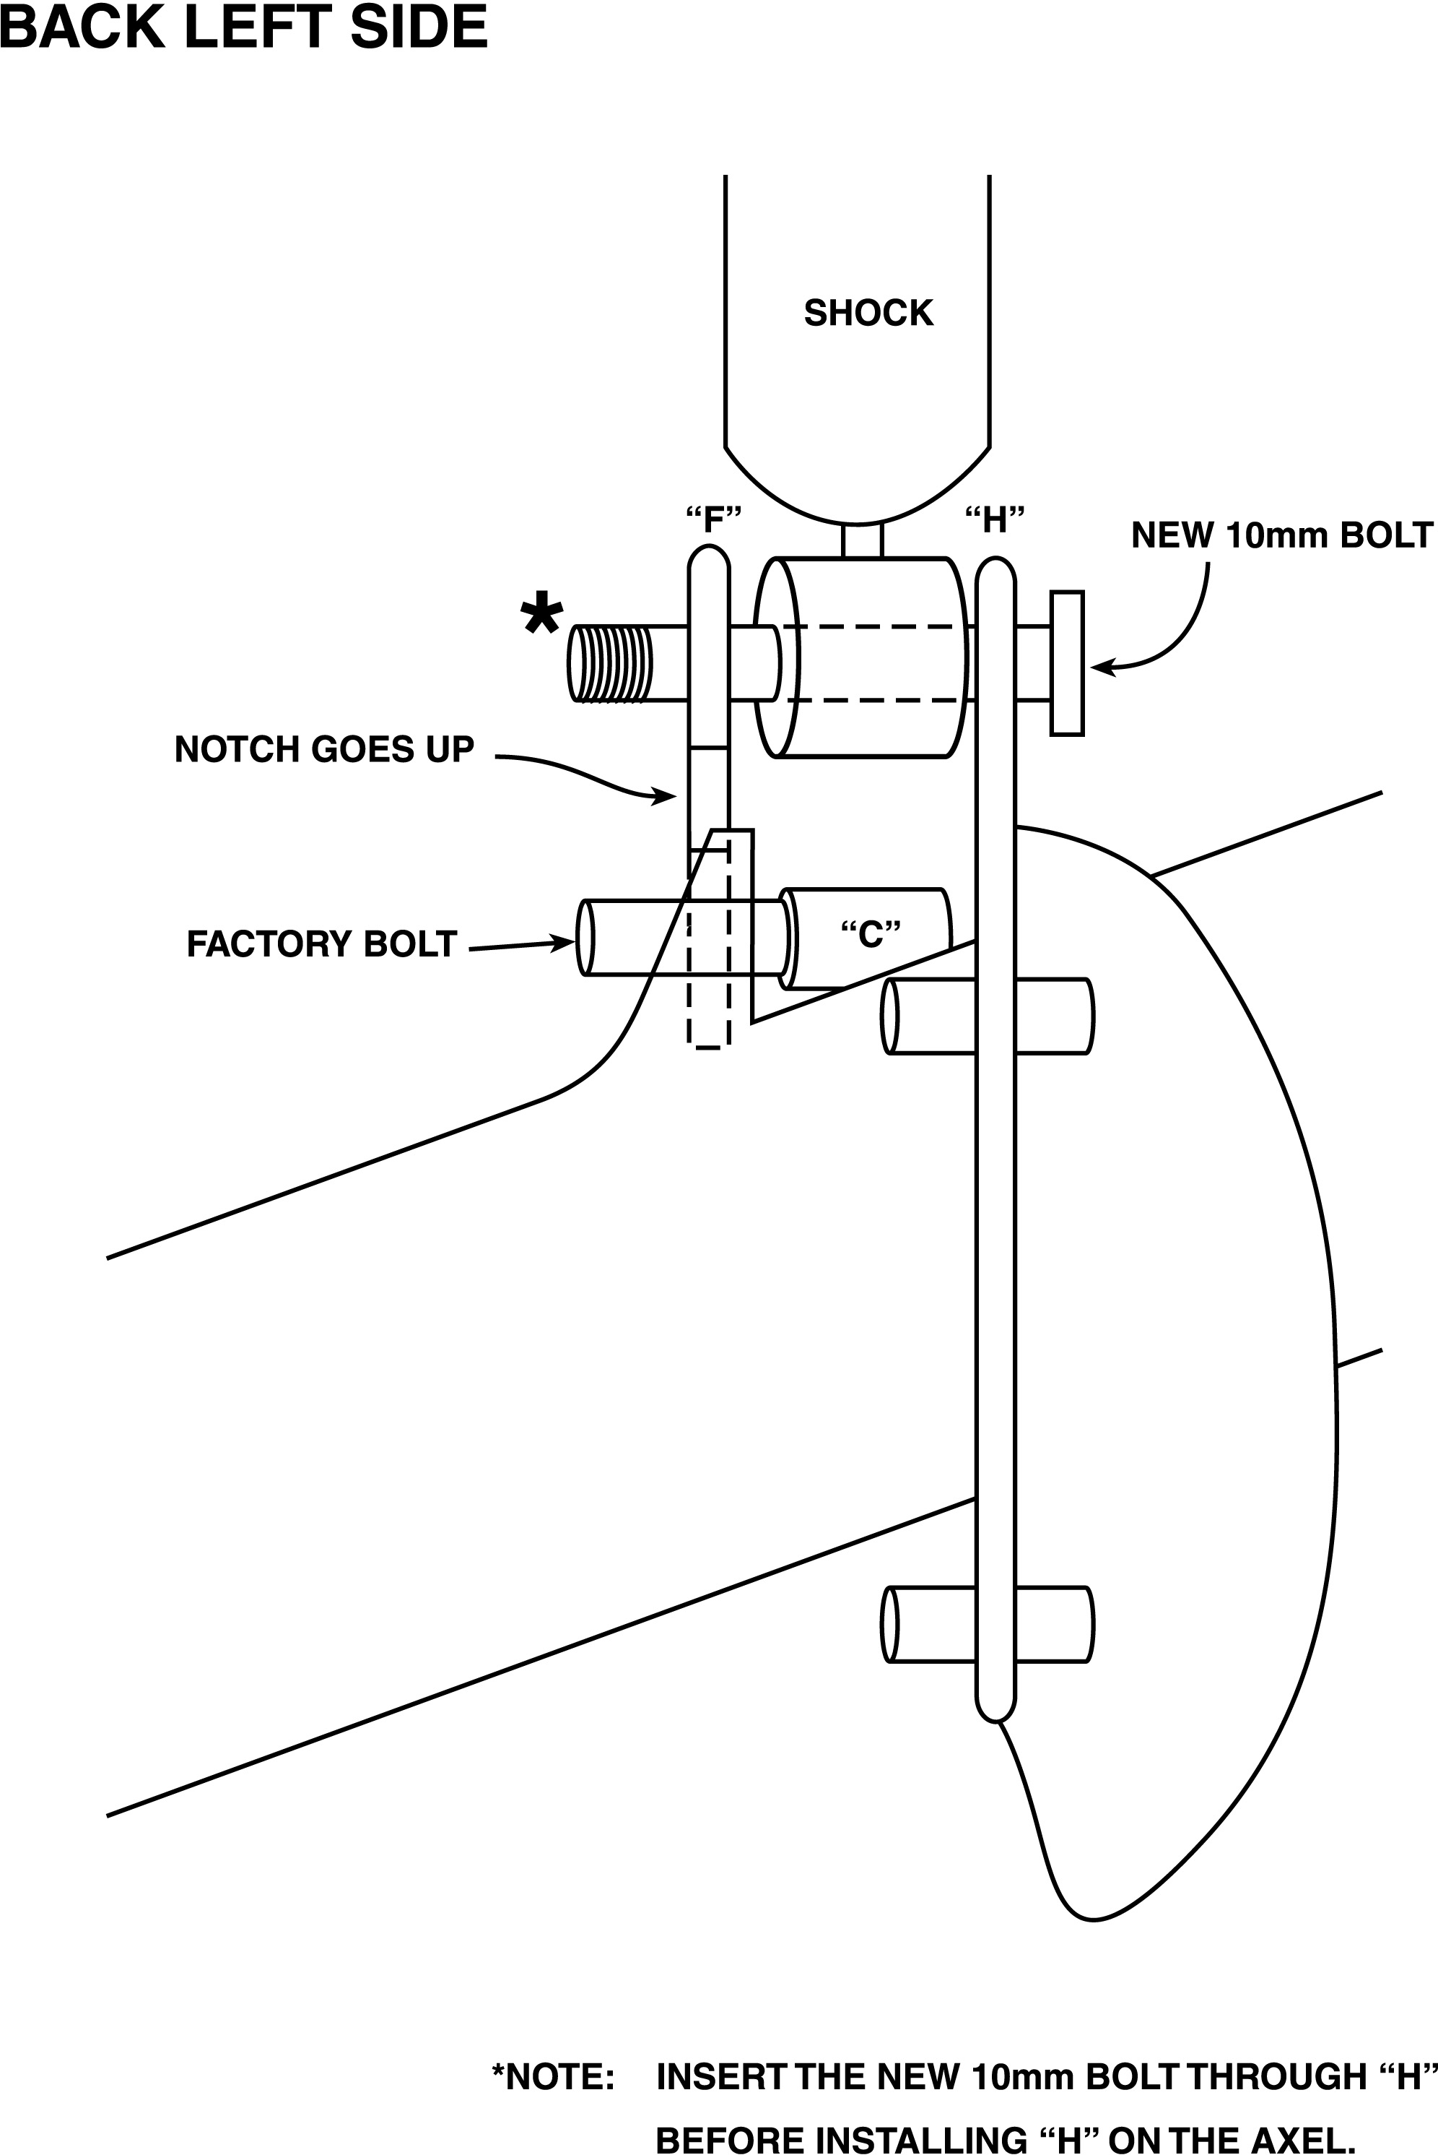

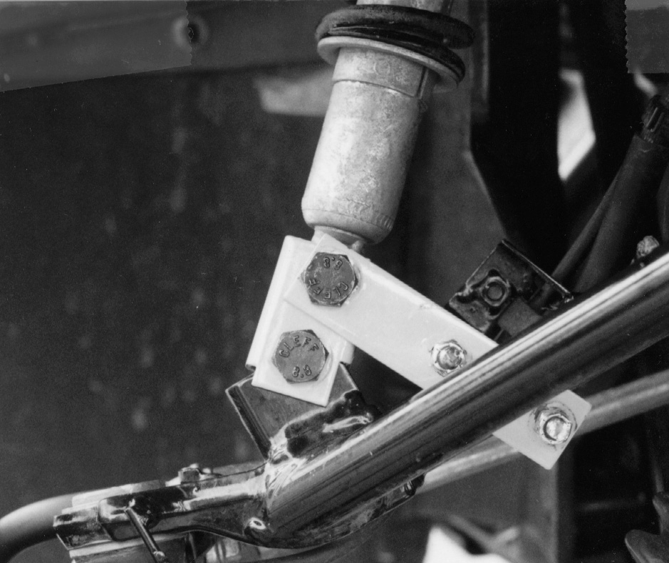
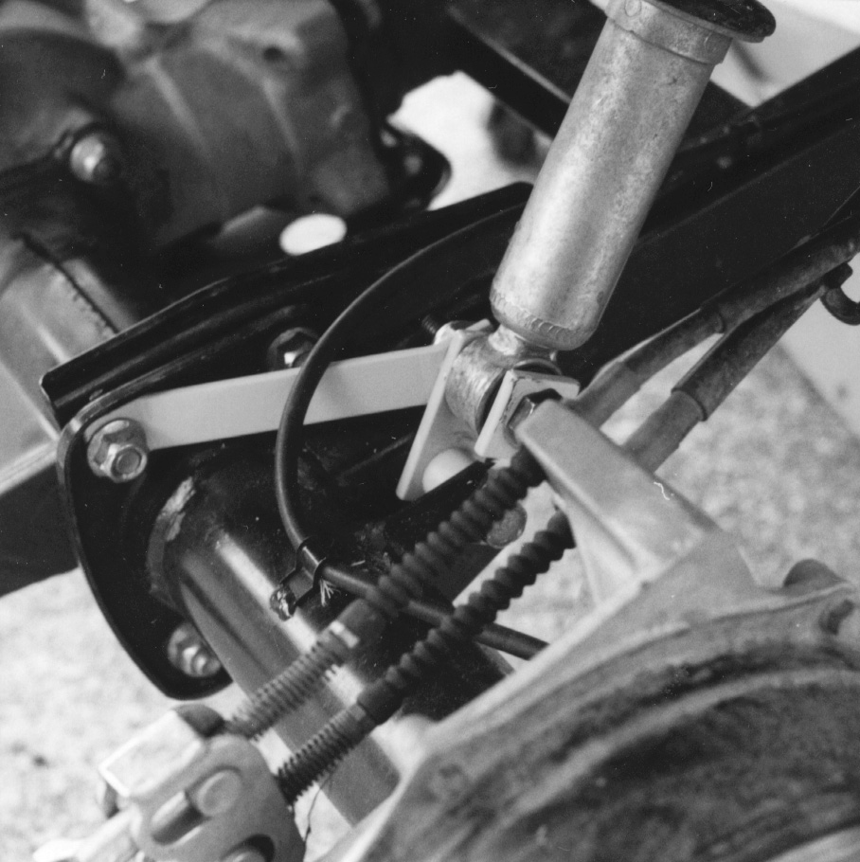
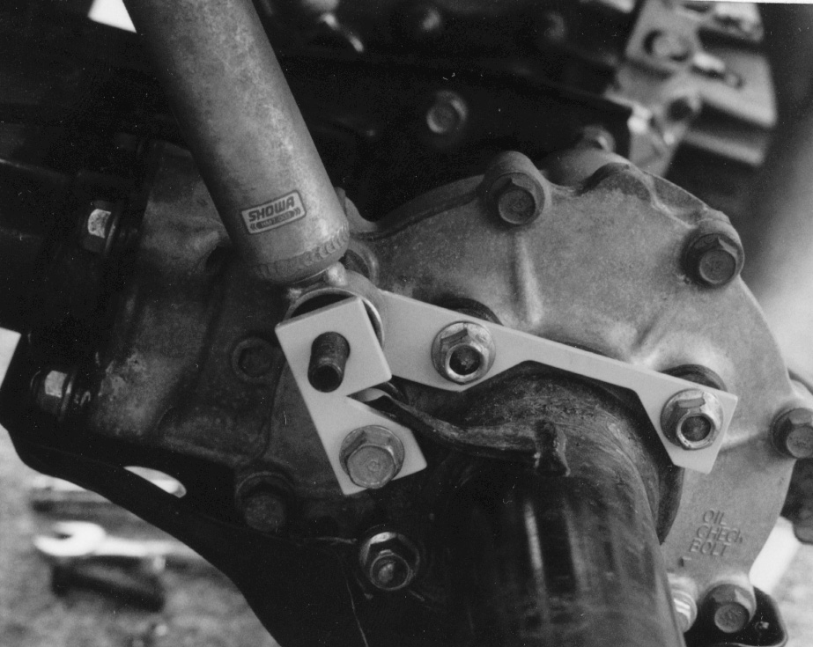

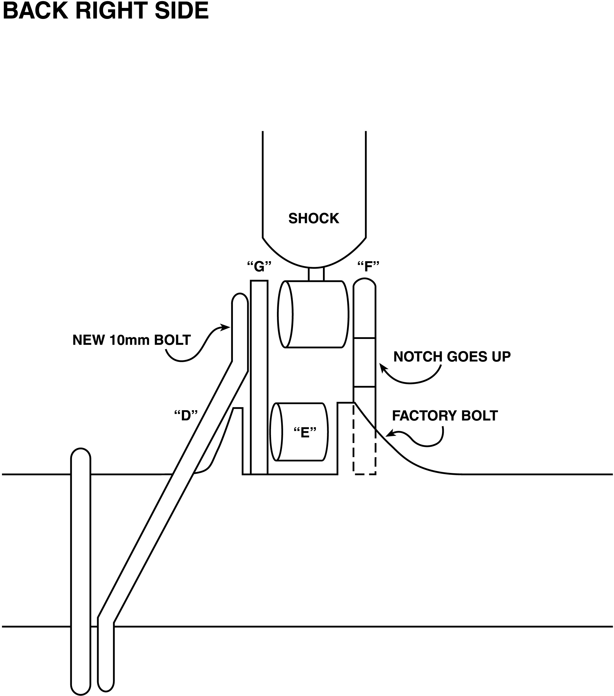

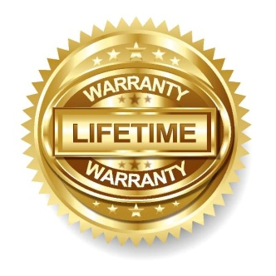
High Lifter Lifetime Warranty
From the beginning, High Lifter has engineered and manufactured some of the toughest, most durable products on the market. That’s why this product comes with a Lifetime Warranty. It’s our promise that High Lifter will never let you down.
- The Lifetime Warranty covers products sold to the original purchaser only and is not transferable. The term of the warranty is for the lifetime of the vehicle in question.
- Normal wear and tear items and finishes, such as, but not limited to: Heim joints, tie rod ends,
ball joints, bearings, seals, bushings, bushing sleeves, zinc plating , powder coating, or chipping and discoloration of any finish is not covered.
- High Lifter will ship the replacement product after the returned product has been inspected by High Lifter staff.
- The warranty shall not include claims for damages, installation time or labor charges, economic losses, inconvenience, transportation, towing, down time, direct or indirect or consequential damages or delay resulting from any defect.
- The warranty does not apply to products that have been improperly applied or improperly installed.
Making a warranty claim
- All claims must be accompanied by the part and the original sales receipt or other acceptable proof of purchase from the original owner.
- All warranties must be accompanied with a Return Merchandise Authorization (RMA) number. (Contact High Lifter at 318-524-2270 or 800-699-0947 for an RMA number)
- When shipping the damaged product:
  - Write the RMA number on the outside of the box.
  - Also include the RMA number, proof of purchase and any notes inside the box.
  - Please keep your tracking number and shipment information.
- The customer is responsible for shipping the product to High Lifter--return shipping within the lower 48 states will be paid by High Lifter products. With all warranty claims, only standard shipping services apply.
- High Lifter will process your order within 24 business hours of receiving the returned item.
- Ship to: High Lifter Products, 7455 Atkinson Dr. Shreveport, Louisiana 71129

